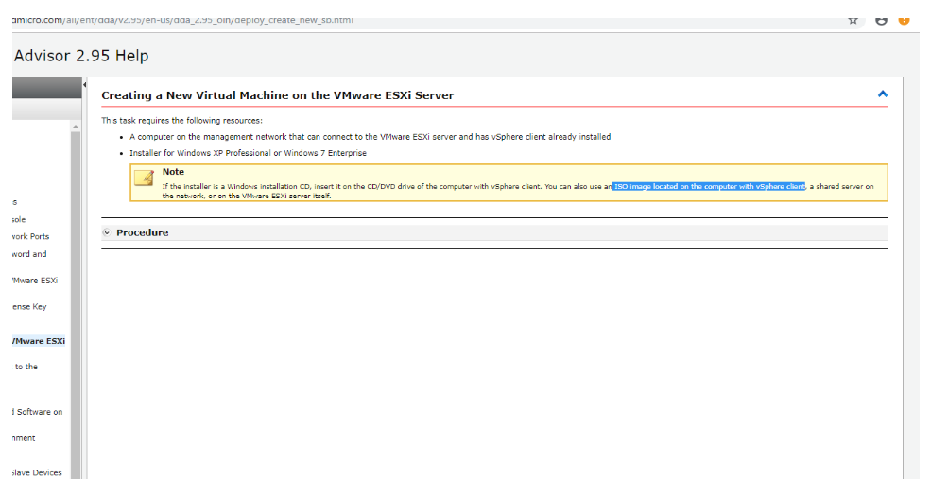

* *What did you accomplish in the time period before this report?*

I accomplished how to enable Virtual Based Security on Virtual machine

* *What do you plan on doing next?*
* *Do you have any obstacles?*

**Attachments**